LED 101
Exploring the basics of LED circuits
In this activity, we’ll learn how to hook up a Light Emitting Diode (LED) to power and make it glow. We’ll also learn why a resistor is required in the LED circuit and how to calculate the proper resistor value.
Secondary skills we’ll learn are: how to use a multimeter, how to use a solderless breadboard, basic concepts of schematic diagrams, series circuits, and how to read resistor color bands.
The skills learned here will serve as a foundation for future endeavors, like the Arduino microcontroller series of activities.

Materials Needed
1 or more LEDs. Red, green, yellow and blue make a good start.
1 220Ω resistor. Color bands: red, red, brown.
1 180Ω resistor. Color bands: brown, gray, brown.
1 150Ω resistor. Color bands: brown, green, brown.
1 5 volt power source.
1 Solderless breadboard.
1 Multimeter (set to measure zero to 20V if manual range.)
1 Set of multimeter leads.
Dry-erase board or paper and pencil for drawing.
Safety glasses or goggles for each participant.

Facilitator Setup
The person running the activity should set up a circuit ahead of time for a reference. The schematic and board layout are shown below. Start with a Red LED.
Be sure to connect the longer lead of the LED to the positive side (red stripe) of the breadboard and one end of the resistor to the ground side (blue stripe.) The short lead of the LED and the remaining lead of the resistor should be connected in the same row.
Apply power after connections are made.
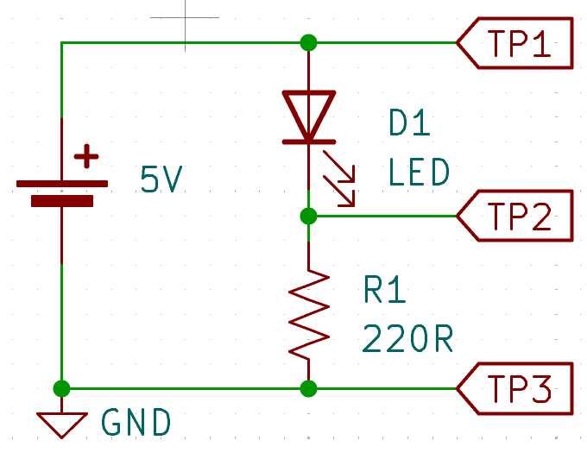  TP is an abbreviation for Test Point. GND is ground. | 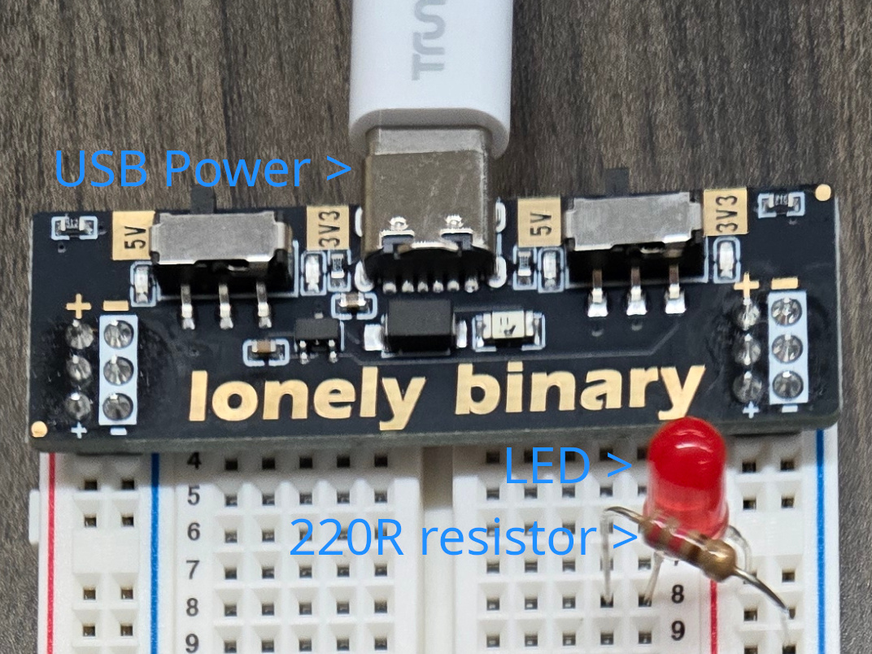

Show and Tell Activity
Participants gather around the facilitator’s LED circuit. The facilitator should draw the circuit and briefly explain the flow of current from the positive terminal of the power supply, through the LED, through the resistor, and back to the ground terminal of the power supply.
Use the multimeter to measure voltages at the various test points. Connect the mulimeter’s common lead to the ground terminal of the power supply. Move the multimeter’s positive lead to each test point and write down the voltage.

Hands-On Activity
Have participants organize into groups of two or three. Pass out supplies to each group. Each group builds the circuit to light their LED, with facilitator troubleshooting as needed.
Participants take turns using the multimeter to measure voltages.

Intermediate Activity
Have each group replace their red LED with another color. Repeat the test point voltage measurements and write them down. Ask participants what conclusions they can draw by comparing these measurements to their original red LED measurements.
The facilitator explains that different colors have different voltages across the LED. Red is generally the lowest and blue is the highest. This means a different resistor value is needed to get the same brightness from each color.

Advanced Activity
If participants are comfortable with basic algebra concepts, the facilitator may wish to explain Ohm’s Law and how to calculate current in the circuit by using the resistor value and the voltage measured across it (with multimeter leads attached to TP1 and TP2.)
Explain how current is the same in all parts of a series circuit, so the current through the resistor is the same as the current through the LED. Also explain that a current of 20 milliamps is often used as a target for good brightness.
Have participants swap out resistor values for their circuits to get as close to 20mA as they can without going over. Red LEDs should have the highest resistor values and blue, the lowest.

Expert Activity
Have participants attach multiple LED/resistor combinations in parallel. Measure voltages across resistors. Get as close to 20mA for each branch of LED/resistor as possible. Facilitator can introduce the concept of parallel circuits and how the voltage across each LED/resistor pair will be the same, because they are in parallel, but the currents will be different depending on the resistor value.
If participants are okay with the math, explain how power can be calculated and determine the wattage needed to get good brightness from each LED.

Mad Science Activity
The facilitator will sacrifice an LED in the name of science. Preferably use a red LED, as these are more common and cheaper. This will burn out the LED. Safety glasses are highly recommended.
Apply power to light up the facilitator’s circuit. Replace the 220Ω resistor with a 150Ω resistor. Measure the voltage across the resistor and calculate the current for the circuit. Reminding participants the current through the resistor is also the current through the LED. How many milliamps is it?
If the LED is still surviving, remove the LED and replace it with a length of wire. See how long it takes to burn out the LED. When the LED is no longer functioning, remove power from the circuit and recycle the LED.

Sample Chart for Recording Voltages
LED color | TP1 | TP2 | TP3 | V_{R1} (calculated) | V_{D1} (calculated)
Red | 4.7V | 3.0V | 0V | 3.0V | 1.7V

Formulas
Some useful formulas for the advanced and expert activities.

Calculating current from voltage and resistance
I = V / R, where I is current, V is voltage, and R is resistance.
I = E / R (an alternate way you might see it, where E is electromotive force a.k.a. voltage.)

Calculating power from voltage and current
P = V x I, where V is voltage, and I is current.
P = I x E (an easy way to remember, because it spells PIE.)

